Matrices as Systems of Equations
Matrices are also used to denote a system of equations. The below system of equations can be written in matrix form:

$$3x+7y= -1$$
$$2x+5y= -1$$
$$\left[\begin{matrix}3 & 7 & -1 \\ 2 & 5 & -1\end{matrix}\right]$$

We’re interested in solving this system of equations (i.e. determining the values of x and y that make both equations true simultaneously). Below are the instructions to have your calculator solve the system of equations in matrix form.
First, input the matrix representing the system of equations in our calculator.
Press 2nd x⁻¹: This brings up the matrix menu.
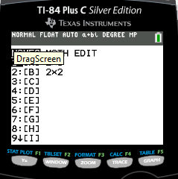
EditSelect a matrixenter the dimensions of the matrix: rows x columns (for this system is would be 2x3)

Type in the values of the coefficients for each variable. The last column is reserved for what the equation is equal to.
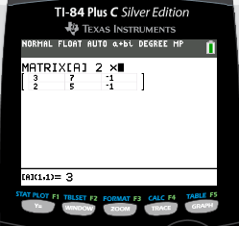

Then return to the home screen by using the QUIT command.
Go back into the matrix menu (Press 2nd x⁻¹) and arrow to the MATH menu. Scroll down to command B: rref
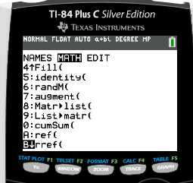
Hit ENTER. Go back into the matrix menu to select your matrix from the list.
Hit ENTER.

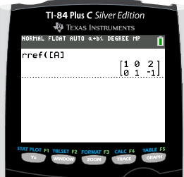

A diagonal of ones will appear. The solution to your system is in the far right column.
(x = 2, y = -1 for this example)

Follow the same process to solve for systems with three variables. Change the dimension to account for the extra equation and variable. It will now be a 3 x 4.
If a diagonal of ones exists, look at the far right column for each answer. If no diagonal of ones, look at the bottom row of your matrix.

Does the bottom row make a true statement?

YES: Then answer is ______________________ NO: Then answer is:___________________

Examples:

$$3x-3y= -6$$
$$z= -3x-3y+9$$
$$-4x+5y+z=8$$

$$x= -5y+4z+1$$
$$x-2y+3z=1$$
$$2x+3y-z=2$$

$$2x+y-z=1$$
$$x+2y+2z=2$$
$$4x+5y+3z=3$$

