Segment and Angle Proofs Additional Practice Hints:

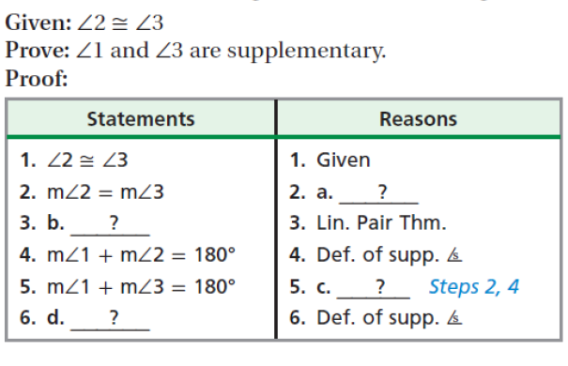

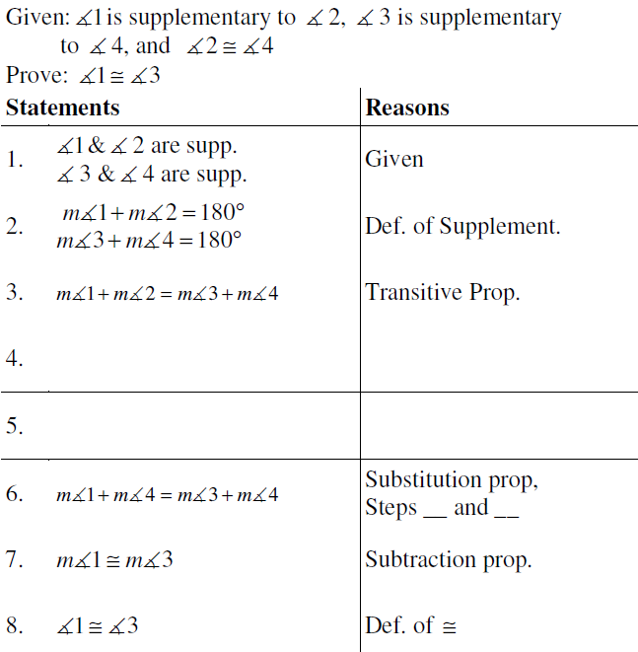

- 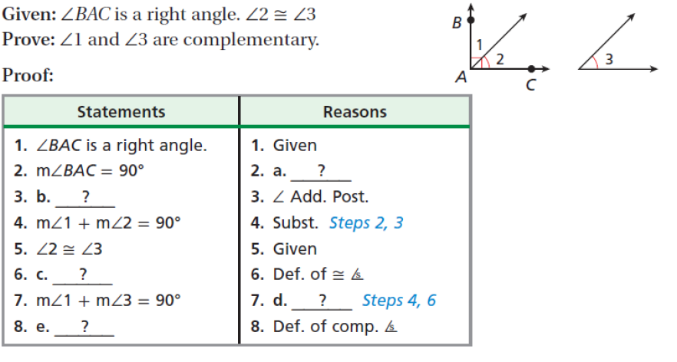

- 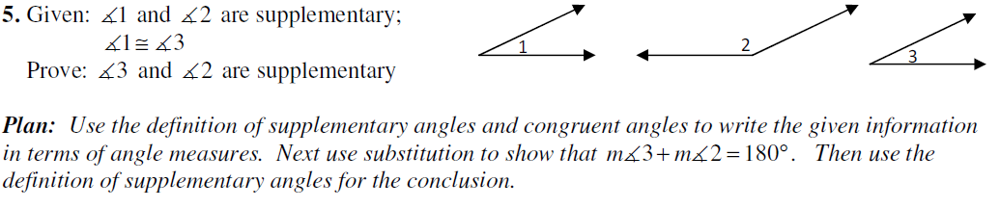

- 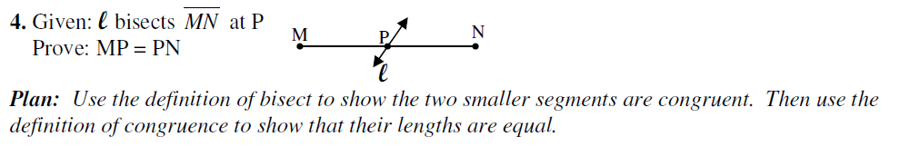

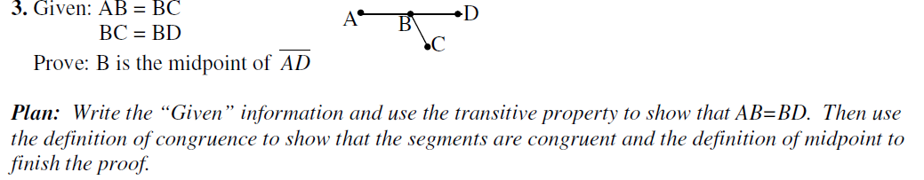
- 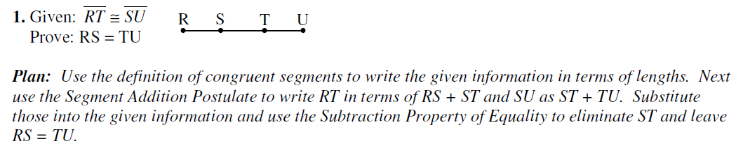

- Show segments are congruent by definition of midpoint. Show measures are equal because they are congruent. Use substitution or transitive property to prove.

- Use addition property to make equivalent congruent segment statements. Use segment addition to show how each segment is created. Substitute to prove.

