Reflections Notes Part 2

Reflection across a specific line:

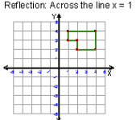

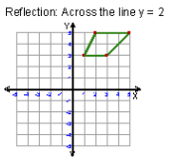

Lines and Points of Symmetry:
line of symmetry: a line where the figure is folded so that the two halves match exactly.
point of symmetry: a point that is a common point of reflection for all points on a figure.
Examples:

